**Department of Information Technology**

**Sem: IV Python Lab 2021-22**

**Assignment**

Q.1) Write a python program to input a string, remove punctuation from a string and then sort words in alphabetic order. (LO1)

**Code:**

punctuations = '''!()-[]{};:'"\,<>./?@#$%^&*_~'''

my_str = input("Enter a string: ")

no_punct = ""

for char in my_str:

if char not in punctuations:

no_punct = no_punct + char

print(no_punct)

words = [word.lower() for word in no_punct.split()]

words.sort()

print("The sorted words are:")

for word in words:

print(word)

**Output:**

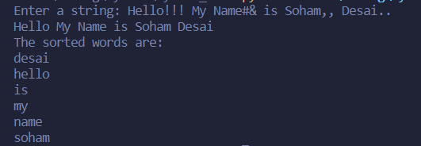

Q.2) Write the following programs (LO2)  
  
i)  Write a python program to count tuples occurrences in given list of tuples and then remove duplicate tuples from list of tuples  
**Code:**

import collections

x = [[('Mon', 'Wed')], [('Mon')], [('Tue')],[('Mon', 'Wed')] ]

a = collections.defaultdict(int)

for elem in x:

a[elem[0]] += 1

print("Count of tuples present in the list:\n",a)

def removeDuplicates(Tuple):

return [t for t in (set(tuple(i) for i in Tuple))]

print(removeDuplicates(x))

**Output:**



ii) Write a python program to create a sub-dictionary containing all keys from dictionary list

**Code:**

from itertools import chain

a = [{'soham' : 3, 'is' : 7},

{'soham' : 3, 'is' : 1, 'best' : 5},

{'soham' : 8}]

print("The original list is : " + str(a))

all_keys = set(chain.from_iterable(a))

res = [dict((key, sub.get(key, None)) for key in all_keys) for sub in a]

print("Reformed dictionaries list : " + str(res))

**Output:**



Q.3) Create a Vehicle class with max_speed and mileage instance attributes. Create a Bus and Taxi classes that inherit the Vehicle class. Give the capacity argument of Bus. The seating_capacity() for bus and Taxi a default value of 50 and 3 respectively. The default fare charge of any vehicle is seating capacity * 100 per 5km. If Vehicle is Bus instance, we need to add an extra 10% on full fare as a maintenance charge. So total fare for bus instance will become the final amount = total fare + 10% of the total fare. Calculate total fare charges spent by group for picnic if both taxi and bus is used for travelling 100km distance one way.  (LO3)

**Code:**

class Vehicle:

def __init__(self, name, mileage, capacity):

self.name = name

self.mileage = mileage

self.capacity = capacity

def show(self):

print("Name:", self.name, "\nMileage:", self.mileage, "\nCapacity:", self.capacity)

class Bus(Vehicle):

def fare(self, distance):

def_fare = 0

def_fare = self.capacity * 20 * distance

print("Fare:", def_fare)

total_bus_fare = def_fare + 0.1 * def_fare

print("Total fare:", total_bus_fare)

class Taxi(Vehicle):

def fare(self, distance):

def_fare = 0

def_fare = self.capacity * 10 * distance

print("Fare:", def_fare)

total_bus_fare = def_fare + 0.05 * def_fare

print("Total fare:", total_bus_fare)

School_bus = Bus("School Volvo", 12, 50)

School_bus.show()

School_bus.fare(100)

taxi = Taxi("Taxi", 10, 10)

taxi.show()

taxi.fare(100)

**Output:**

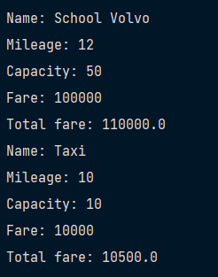

Q.4) Create module for performing mathematical function and import it to calculate Euclidean distance. Show exception handling to handle the runtime mistake done by user. (LO4)

**Code:**

import math

class MyMathLibrary:

@staticmethod

def calculateEuclideanDistance(x1, x2, y1, y2):

xMinus = x2 - x1

yMinus = y2 - y1

internalCalc = xMinus**2 + yMinus**2

euclidDistance = math.sqrt(internalCalc)

return euclidDistance

import mathmodule

try:

x1 = float(input("enter the x1 co-ordinate value : "))

x2 = float(input("enter the x2 co-ordinate value : "))

y1 = float(input("enter the y1 co-ordinate value : "))

y2 = float(input("enter the y1 co-ordinate value : "))

myResult = mathmodule.MyMathLibrary.calculateEuclideanDistance(x1, x2, y1, y2)

print(f"The Euclidean Distance Of X1 : {x1}, X2 : {x2}, Y1 : {y1}, Y2 : {y2} Is {myResult} units.")

except:

print("kindly enter valid co-ordinates value.")

**Output:**

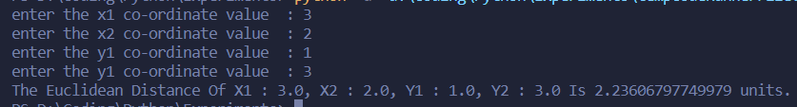

Q.5) Develop GUI Application for E-commerce application use (LO5)  
  
1) file, pickle, dictionary  to show add, delete, update operations.

**Code:**

import sys, pickle

from PyQt5.QtWidgets import QApplication, QWidget, QGridLayout, QLabel, QLineEdit, QPushButton, QTableWidget, QTableWidgetItem, QMessageBox

class dictionary(dict):

def init(self):

self = dict()

def add(self, key, value):

self[key] = value

def delete(self, key):

self.pop(key)

def main(self):

s = dictionary()

def add():

name = nameLine.text()

price = priceLine.text()

s.add(name, price)

print(s)

row = table.rowCount()

table.setRowCount(row + 1)

namecell = QTableWidgetItem(name)

pricecell = QTableWidgetItem(price)

table.setItem(row, 0, namecell)

table.setItem(row, 1, pricecell)

def delete(self):

selected = table.selectedItems()

name = selected[0].text()

selectedIndex = table.selectedIndexes()

rowNo = selectedIndex[0].row()

table.removeRow(rowNo)

s.delete(name)

print(s)

def save(self):

file = open("shopping.pickle", "wb")

pickle.dump(s, file)

file.close()

print("Data saved!")

def upload(self):

file = open("shopping.pickle", "rb")

temp = pickle.load(file)

for name, price in temp.items():

print(name, price)

s.add(name, price)

row = table.rowCount()

table.setRowCount(row + 1)

namecell = QTableWidgetItem(name)

pricecell = QTableWidgetItem(price)

table.setItem(row, 0, namecell)

table.setItem(row, 1, pricecell)

file.close()

def bill():

file = open("shopping.pickle", "rb")

temp = pickle.load(file)

sum = 0

for Name, price in temp.items():

print(Name, price)

sum += float(price)

msg = QMessageBox()

msg.setWindowTitle("Cash Invoice")

msg.setText("Your bill amount is " + str(sum))

x = msg.exec_()

file.close()

app = QApplication(sys.argv)

w = QWidget()

layout = QGridLayout()

nameLabel = QLabel()

nameLabel.setText("Name of Product :")

nameLine = QLineEdit()

priceLabel = QLabel()

priceLabel.setText("Price :")

priceLine = QLineEdit()

emptyLabel = QLabel()

emptyLabel.setText("***Product Names And Prices****")

addButton = QPushButton()

addButton.setText("Add Record")

delButton = QPushButton()

delButton.setText("Delete Record")

saveButton = QPushButton()

saveButton.setText("Save Record")

uploadButton = QPushButton()

uploadButton.setText("Upload Record")

billButton = QPushButton()

billButton.setText("View bill")

billButton.clicked.connect()

table = QTableWidget()

table.setColumnCount(2)

table.setHorizontalHeaderLabels(["Name of Product", "Price"])

table.resizeColumnToContents(0)

table.resizeColumnToContents(1)

table.setWordWrap(True)

addButton.clicked.connect(add)

delButton.clicked.connect(delete)

saveButton.clicked.connect(save)

uploadButton.clicked.connect(upload)

w.resize(550, 350)

w.setWindowTitle("Shopping List")

layout.addWidget(nameLabel, 1, 1)

layout.addWidget(nameLine, 1, 2)

layout.addWidget(priceLabel, 2, 1)

layout.addWidget(priceLine, 2, 2)

layout.addWidget(addButton, 3, 1)

layout.addWidget(delButton, 3, 2)

layout.addWidget(saveButton, 3, 3)

layout.addWidget(uploadButton, 3, 4)

layout.addWidget(billButton, 3, 5)

layout.addWidget(emptyLabel, 4, 2)

layout.addWidget(table, 5, 2)

w.setLayout(layout)

w.show()

sys.exit(app.exec_())

if __name__ == " main ":

d = dictionary()

d.main()

2) sqlite3 dictionary  to show add, delete, update operations.

**Code:**

from tkinter import *

import sqlite3

top = Tk()

top.geometry("750x700")

conn = sqlite3.connect('products.db')

print("Database established succesfully!")

cur = conn.cursor()

cur.execute( """CREATE TABLE IF NOT EXISTS PRODUCTS(NAME TEXT,PRICE TEXT,QUANTITY TEXT)""") # write SQL queries in () print("Products table created succesfully")

conn.commit()

conn.close()

s1 = e1.get()

s2 = e2.get()

s3 = e3.get()

print(s1, s2, s3)

conn = sqlite3.connect('products.db')

print("Attempting to open the database")

cur = conn.cursor()

val = (s1, s2, s3)

cur.execute('''INSERT INTO PRODUCTS(NAME,PRICE,QUANTITY) VALUES (?,?,?)''', val)

conn.commit()

print("Values fed into database: ", val)

l_add = Label(top, text="Record inserted successfully")

l_add.place(x=200, y=300)

conn.close()

def view():

conn = sqlite3.connect('products.db')

print("Attempting to open the database")

cur = conn.cursor()

cur.execute('''SELECT * FROM PRODUCTS''')

records = cur.fetchall() # record = str(records)

print("Records in the database are: ", str(records))

l_view = Label(top, text="Records in the Table products are: ")

l_view.place(x=200, y=380)

T = Text(top, height=10, width=50)

T.place(x=200, y=440)

T.insert(INSERT, str(records))

conn.commit()

conn.close()

def delete():

conn = sqlite3.connect('products.db')

print("Attempting to open the database")

cur = conn.cursor()

n1 = e4.get()

print(n1)

cur.execute('''DELETE FROM PRODUCTS WHERE NAME = ?''', (n1,))

l_del = Label(top, text="Record deleted")

l_del.place(x=450, y=150)

conn.commit()

conn.close()

l_main = Label(top, text="Available Products", font=("Helvetica 25 bold "), fg="violet", bg="orange")

l_main.place(x=20, y=20)

l_name = Label(top, text="Name of product", font=('Helvetica 12 bold'))

l_name.place(x=20, y=80)

e1 = Entry(top)

e1.place(x=200, y=80)

l_price = Label(top, text="Price", font=('Helvetica 12 bold'))

l_price.place(x=20, y=120)

e2 = Entry(top)

e2.place(x=200, y=120)

l_quantity = Label(top, text="Quantity", font=('Helvetica 12 bold'))

l_quantity.place(x=20, y=160)

e3 = Entry(top)

e3.place(x=200, y=160)

l_n = Label(top, text="Product Name to be deleted", font=('Helvetica 12 bold'))

l_n.place(x=350, y=80)

e4 = Entry(top)

e4.place(x=600, y=80)

b1 = Button(top, text="ADD", font=('Helvetica 12 bold'), command=insert)

b1.place(x=20, y=240)

b2 = Button(top, text="VIEW", font=('Helvetica 12 bold'), command=view)

b2.place(x=100, y=240)

top.mainloop()

**Output:**

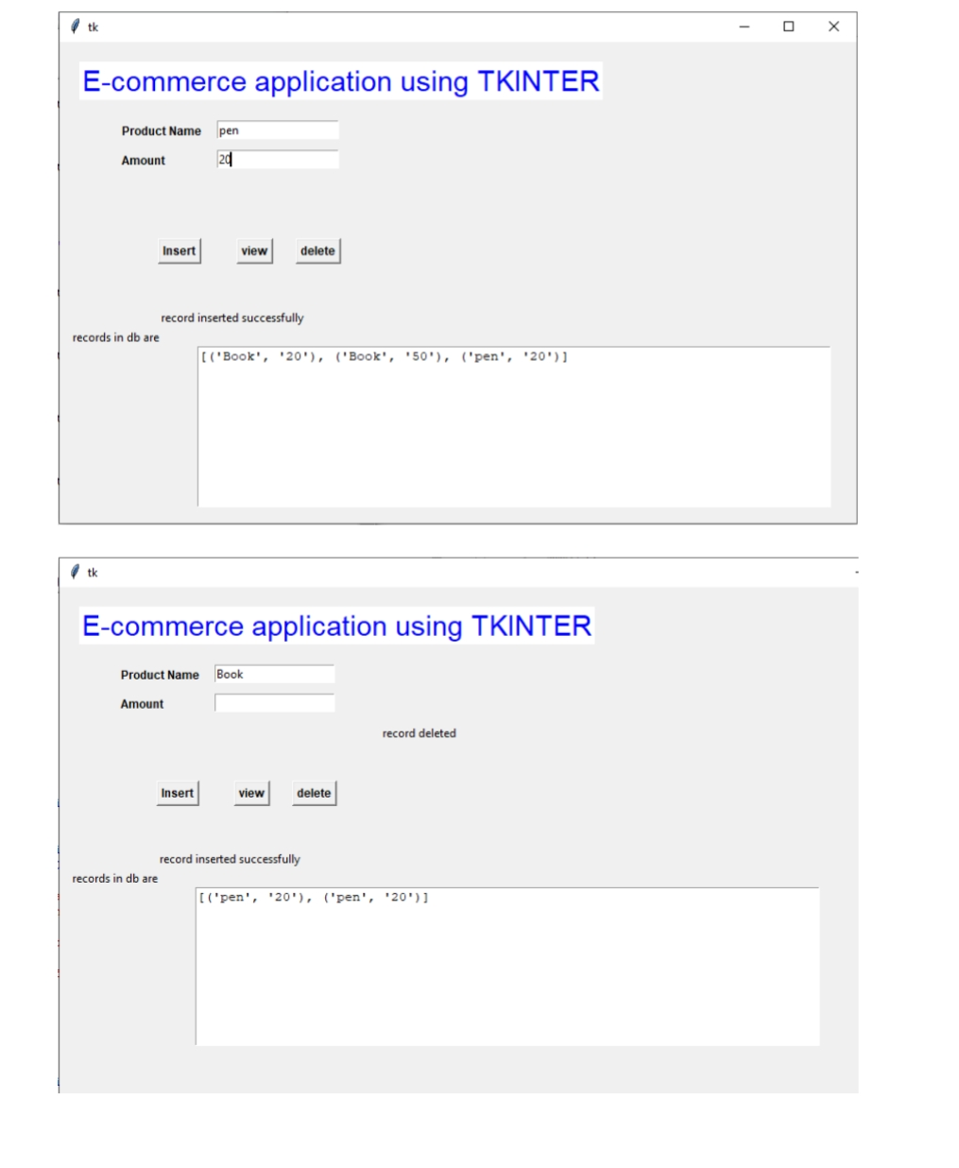

Q.6) Prepare a graph showing attendance analysis of SE IT students (attendance sheet is uploaded on Google classroom) (LO6)

**Code:**

import pandas as pd

import matplotlib.pyplot as plt

import numpy as np

df = pd.read_csv('atten.csv')

rollNo = df['Roll_no'].values

a = np.arange(len(rollNo))

w = 0.5

plt.bar(a, df['Sub1'].values, width=w, color='r',label='Sub1')

plt.bar(a+w, df['Sub2'].values, width=w, color='g',label='Sub2')

plt.bar(a+2*w, df['Sub3'].values, width=w, color='b',label='Sub3')

plt.bar(a+3*w, df['Sub4'].values, width=w, color='y',label='Sub4')

plt.bar(a+4*w, df['Sub5'].values, width=w, color='c',label='Sub5')

plt.xticks(a+w, rollNo)

plt.legend()

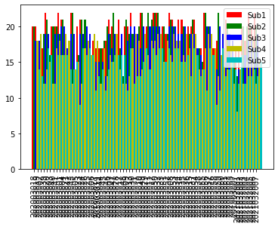plt.show()